
Certification in Scientific Writing
Phase 1 Undertaking Form

I, Yash Pramod Deotale, a 1st year Ph.D. student in the Discipline of Earth Sciences, affirm that:

- I have read and understood the format guidelines for the Phase-1 submissions, which were shared by the Certification in Scientific Writing team at the beginning of Phase 1.

- I did not seek assistance from my Faculty Advisor and any other individuals, as well as indulge in any other malpractice, for completing the tasks for this Certification. My written submissions were my original written work.

- I have attached the Turnitin report of my manuscript/proposal, which received a ___% similarity score.

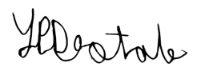
Name and Signature of Participant: Yash Pramod Deotale
Roll No: 24210116
Date: 12/03/2026

Name and Signature of Faculty Advisor: Dr. Achyut Mishra
Date: 12/03/2026

